Support for People with Autism
Bromley Well supports people with Autism aged 16+
- Support with transition into adulthood
- Social and leisure activities
- Health matters
- Managing your money, grants, and benefits
- Managing communications, letters, forms, and applications
- Support with employment
- Life skills training
- Signposting to further services
- Housing
We also offer monthly workshops and regular peer support activities.
@BromleyWellservices @BromleyWell
For further information please contact Bromley Well on freephone 0808 278 7898 or email spa@bromleywell.org.uk www.bromleywell.org.uk

spa@bromleywell.org.uk

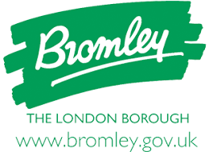
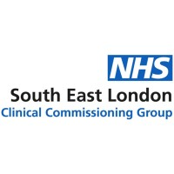
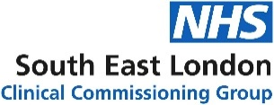
Funded by Delivered by

