Useful digital links and resources – CV19 2020

Here is a list of some of useful links/resources we have managed to collate together. This list will be updated and amended regularly. Please feel free to share any tips, ideas and suggestions to this list which is not exhaustive.

General advice and information

For general information and government advice: https://www.gov.uk/coronavirus

For specific advice for extremely vulnerable people: https://www.gov.uk/coronavirus-extremely-vulnerable

The London Borough of Bromley request for assistance link: https://www.bromley.gov.uk/requestforassistanceform
For those vulnerable residents who are unable to access the online form, there is now a Bromley Council COVID-19 Assistance telephone helpline, which is operated weekdays from 8:30am to 5pm: 020 8313 4484. (This helpline is strictly for those who have no other means of getting help and cannot make contact with the Council online).
The Bromley Local Offer for SEND children: www.bromley.gov.uk/localoffer

For the latest new from Bromley Council: https://www.bromley.gov.uk/info/200109/council_news

The Bromley Children Project
Here at the Bromley Children Project, we recognise that the current Government guidelines on Covid 19 are not helpful to families; children, whether small or large, will find it difficult to be indoors every day and, as a result, children’s behaviour may be more challenging and parents are likely to feel more stressed. We have discussed how we can continue to support our Bromley families and are happy to tell you that we shall be launching a Parenting Hotline as from Thursday 26th March. If you have a parenting issue you would like to get some advice on, or even just reassurance that what you are doing is appropriate, please ring the Hotline number which is 0208 461 7259. You will be asked some basic details and then someone will call you back for a chat. If your call is not answered straight away, please leave a message, with contact details, and one of the team will call you back.

National voucher scheme launched for schools providing free school meals
Parents will receive the voucher through their child’s school, which can then be redeemed online via a code, or sent to their house as a gift card and used at supermarkets across the country.
Today, schools will receive an email from the Department for Education’s chosen supplier, Edenred, explaining how to access and Children eligible for free school meals can benefit from a national voucher scheme whilst they stay at home. This delivers on the Government’s commitment to provide ongoing support for the 1.3 million children that would receive benefits-related free school meals at their school.
Schools can now provide every eligible child with a weekly shopping voucher worth £15 to spend at supermarkets while schools are closed due to coronavirus.
Schools can continue to provide meals for collection or delivery themselves, but where this is not possible, the scheme will allow schools to provide vouchers to families electronically, or as a gift card for those without internet access.
administer the voucher scheme locally.
Full details of this scheme can be found here:
• https://www.gov.uk/government/publications/covid-19-free-school-meals-guidance

Community Support

Most areas have set up specific support locally:
Kent Covid 19 Mutual Aid Support Group
Add the link to your WhatsApp or Facebook groups below on this thread and help spread the message.
https://www.facebook.com/groups/1093009801049456/permalink/1097498657267237?sfns=mo
https://www.facebook.com/groups/1093009801049456/permalink/1095419410808495/
We have managed to speak to some of the local supermarket chains and they have informed us, that you may be able to shop during the vulnerable persons time slots (check with each store before you visit, as times and access may vary, from store to store). You may need to produce ID to prove you are caring for a vulnerable person. These could include; Blue Badge, DLA forms/Passport. Some of the local groups; Bromley - Covid – 19 Bromley aid may be able to support you or the extremely vulnerable link (both can be found above). Please only use these services if you are really in need, as all services will be highly stretched and we need to ensure that the neediest, receive the help they need.
Please find below some resources that may be helpful for parent carers of children and young people with SEND or children and young people themselves.
- National Autistic Society – guidance and helpline for parents’, young people and staff: https://www.autism.org.uk/services/nas-schools/vanguard/news/2020/march/coronavirus-(covid-19)-advice.aspx
- Mencap - Easy Read guide to Coronavirus: https://www.mencap.org.uk/sites/default/files/2020-03/Information%20about%20Coronavirus%20ER%20SS2.pdf
- Place2Be – Guide to helping parents answer questions from their children and to support family wellbeing: https://www.place2be.org.uk/about-us/news-and-blogs/2020/march/coronavirus-information-for-children/
- Young Minds - Talking to your child about Coronavirus and 10 tips from their Parents Helpline to support family wellbeing: https://youngminds.org.uk/blog/talking-to-your-child-about-coronavirus/
- Carers UK - Guidance for carers: https://www.carersuk.org/help-and-advice/health/looking-after-your-health/coronavirus-covid-19
- Covibook – an interactive resource designed to support and reassure children aged 7 and under, designed to help children explain and draw the emotions that they might be experiencing during the pandemic: https://www.mindheart.co/descargables
- Amaze - information pack for parents https://amazesussex.org.uk/faqs-about-the-coronavirus-for-parent-carers-of-children-with-send-brighton-hove/
- Public Health England have produced an easy read version of their Advice on the coronavirus for places of education. You can download it here.

- Beacon House School: https://beaconschoolsupport.co.uk/newsletter/how-to-talk-to-children-about-coronavirus
- Bromley School Closures: https://www.bromley.gov.uk/press/article/1595/coronavirus_covid-19_school_closures_guidance
- Government guidance on school closures: https://www.gov.uk/government/publications/closure-of-educational-settings-information-for-parents-and-carers?utm_source=3af9bd53-8b24-49d0-92be-34d607ef773a&utm_medium=email&utm_campaign=govuk-notifications&utm_content=immediate
- Family Lives: https://www.familylives.org.uk/how-we-can-help/confidential-helpline/
Future Learn – COVID-19 Coronavirus - Online Course - Future Learn
- Family Lives Habitica – scheduling app: https://habitica.com/static/home

NHS
- Apps for mental health: https://www.nhs.uk/apps-library/category/mental-health/
- Change4Life: https://www.nhs.uk/change4life/about-change4life
- Live Well: https://www.nhs.uk/Conditions/stress-anxiety-depression/
- Place2Be: Coronavirus: Helpful information to answer questions from children
- Together for Short Lives https://www.togetherforshortlives.org.uk/get-support/supporting-you/family-resources/coronavirus-qa/
- WHO – helping children cope with stress https://www.epi-win.com/all-resources/helping-children-cope-with-stress-during-the-covid-19-outbreak#163961_20200318052635
- Young Minds: Talking to your child about Coronavirus and 10 tips from their Parents Helpline to support family wellbeing: https://youngminds.org.uk/blog/talking-to-your-child-about-coronavirus/
- Looking after your mental health while self-isolating https://youngminds.org.uk/blog/looking-after-your-mental-health-while-self-isolating/
- Parents Helpline: If you are a parent who needs advice about your child’s mental health you can contact the Parents Helpline directly on 0808 802 between 9:30am-4pm

Useful tips and learning ideas for children: https://www.facebook.com/groups/662431701225604/permalink/670826077052833/

Audible stories for children: https://stories.audible.com/start-listen
Online sensory resources: http://www.thesensoryprojects.co.uk/covid19-resources
Story re: CV19 for children: https://carolgraysocialstories.com/wp-content/uploads/2020/03/Pandemics-and-the-Coronavirus.pdf
Autism resources for CV19: https://theautismeducator.ie/wp-content/uploads/2020/03/The-Corona-Virus-Free-Printable-Updated-2-The-Autism-Educator-.pdf

Bromley Film Club Sign up here to take part in free screenings, a virtual bake-along with The Cooking Shed and a live stop motion animation demonstration with animator Tim Allen (Isle of Dogs, Fantastic Mr Fox etc). Once you are registered you will receive an email with all joining details. https://www.eventbrite.co.uk/e/from-europe-with-love-tickets-98305579635
You do not need to be part of any paying platform in order to watch these films. The links to the films are password protected and the password will give you entry for this weekend only. Check out their Facebook page for more updates and information.

Online dance classes Coronavirus-19 Free Online Dance Classes for the Community. This group has been set up to bring people together, teach dance for FREE live from Street Dance World and European Championship Winner Belle Fisher. Children, Adults, Everyone can get involved. In the upcoming weeks many families could be self-isolating and will need something to occupy their children. Join Free Online Dance Classes from Belle and many other well-known dancers across the country! https://www.facebook.com/groups/2977147415657912/?ref=share
Utility Support – Gas and Electric - Contact your provider if you are having difficulties and have a prepay meter, tell them you are self-isolating and they may be able to support you with 2 weeks’ worth of gas /electricity, or if you have a smart meter they may be able to top you up.

BRITISH GAS 0333 202 9802

EDF 0333 200 5100

EON 0345 052 000

N POWER 0800 073 3000

SCOTTISH POWER 0800 027 0072

SSE 0345 026 2658
Coronavirus lockdown can be a dangerous time for victims of domestic abuse – here are some links to support:
In an emergency, call 999 - You can also email for support. It is important that you specify when and if it is safe to respond and to which email address:

In an emergency, call 999 - You can also email for support. It is important that you specify when and if it is safe to respond and to which email address:

Or alternatively you can: Talk to a doctor, health visitor or midwife.

Women can call The Freephone National Domestic Abuse Helpline, run by Refuge on 0808 2000 247 for free at any time, day or night. The staff will offer confidential, non-judgemental information and support.

Men can Men's Life Advice on 0808 8010 327 (Monday and Wednesday, 9am to 8pm, and Tuesday, Thursday and Friday, 9am to 5pm) for non-judgemental information and support.

Men can also call Mankind on 0182 3334 244 (Monday to Friday, 10am to 4pm) If you identify as LGBT+ you can call Galop on 0800 999 5428 for emotional and practical support.

Anyone can call Karma Nirvana on 0800 5999 247 (Monday to Friday 9am to 5pm) for forced marriage and honour crimes. You can also call 020 7008 0151 to speak to the GOV.UK Forced Marriage Unit.

Women can email helpline@womensaid.org.uk. Staff will respond to your email within 5 working days men can email info@mensadviceline.org.uk

LGBT+ people can email help@galop.org.uk

The Survivor's Handbook from the charity Women's Aid is free and provides information for women on a wide range of issues, such as housing, money, helping your children, and your legal rights.

If you are worried that you are abusive, you can contact the free Respect helpline on 0808 802 4040.

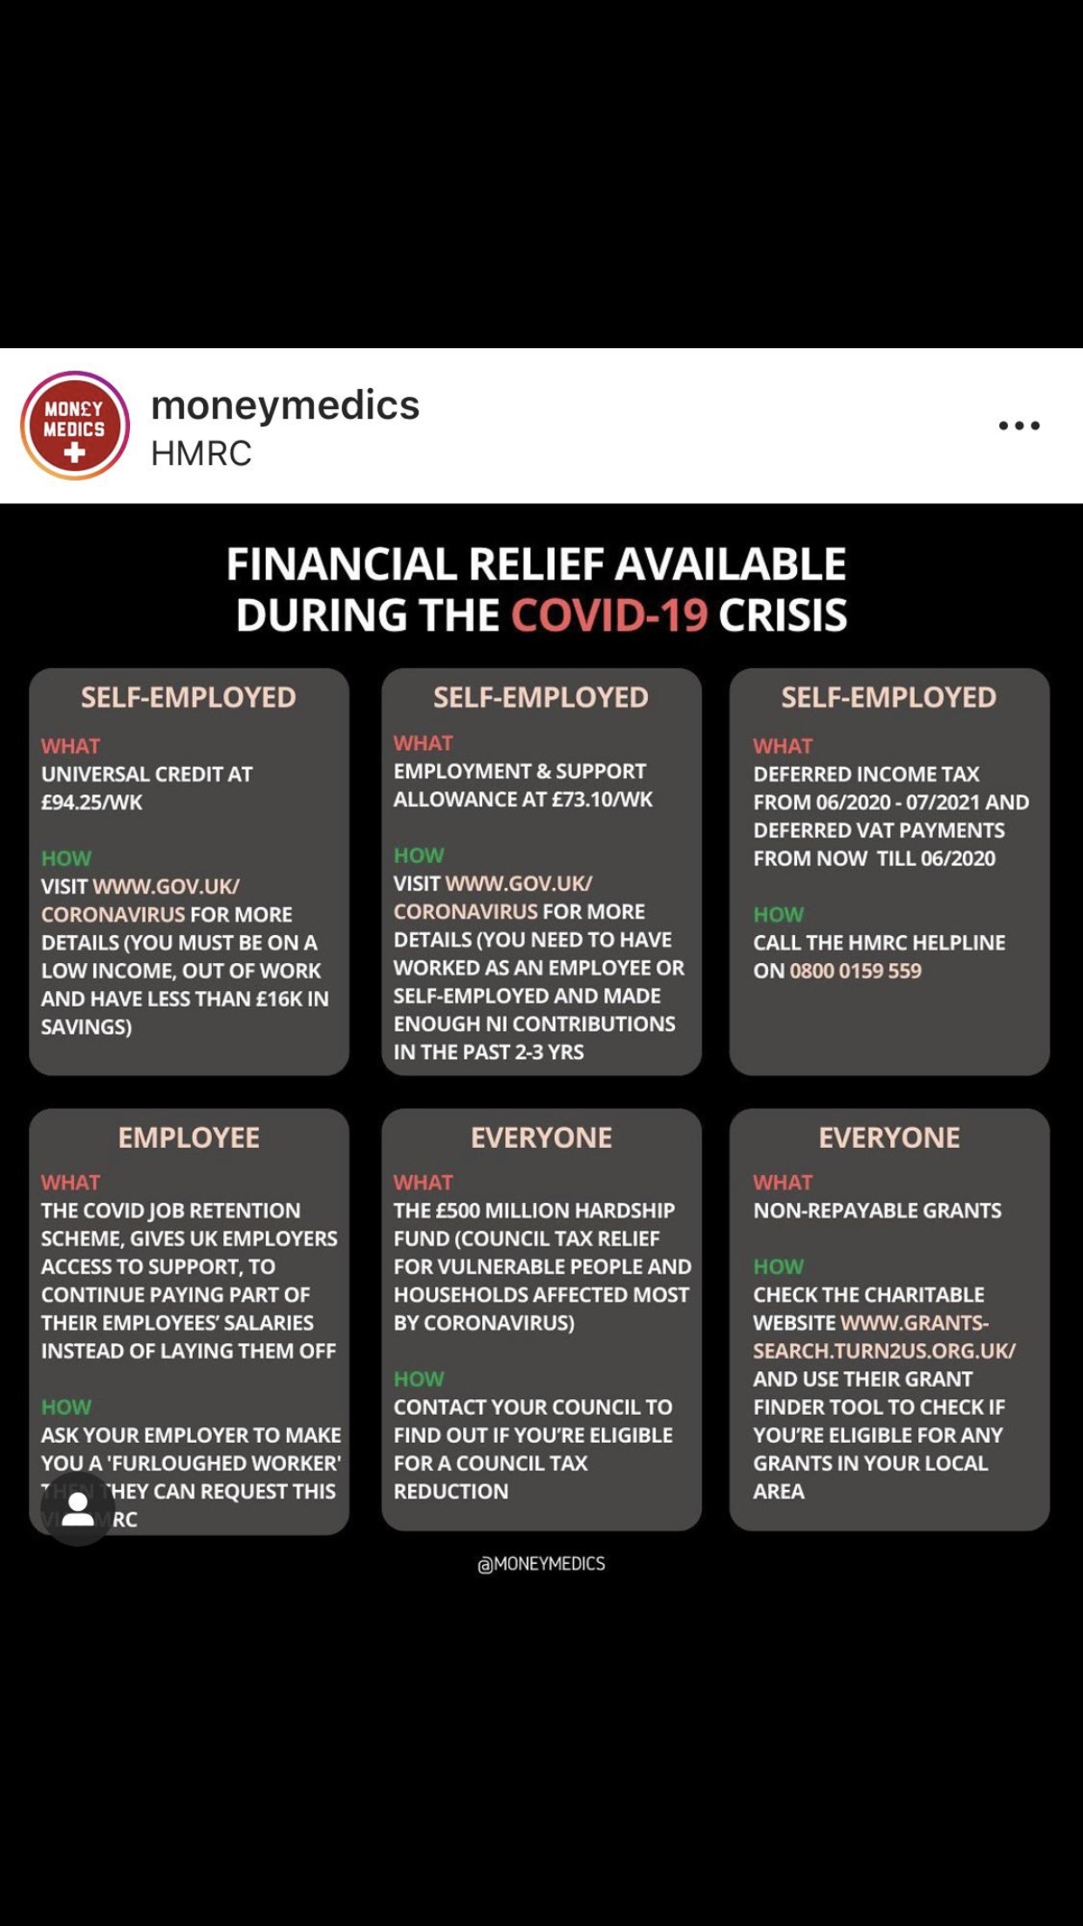
The Open University is running some free courses available to individuals during this period. For more information go to:

https://www.open.edu/openlearn/free-courses/full-catalogue

Art of Living is providing free online meditation sessions for the community to help boost resilience, manage their stress and anxiety and keep the mind calm.

Meditation will help improve overall wellness and health and keep a positive frame of mind.

Zoom link for meditation - The online session details are as follows:

Time: Daily at 06:00 PM London
Join Zoom Meeting
https://us04web.zoom.us/j/2142161526
Meeting ID: 214 216 1526

Here are some ideas for indoor activities for children with ADHD, from an American site: www.understood.org – some of the words are a bit different, but it’s got great activities.
https://www.understood.org/en/school-learning/learning-at-home/games-skillbuilders/cabin-fever-indoor-activities-for-hyperactive-kids
https://www.understood.org/en/school-learning/stuck-at-home-activities?_ul=1*88uetk*domain_userid*YW1wLUVpVFNtNjNlVmVxTHo4WXhrMlZET2c.
Also, Family Lives has useful information and a parent’s helpline
https://www.familylives.org.uk/advice/your-family/family-life/coping-practically-and-emotionally-during-the-covid-19-outbreak/
Links to Government and NHS advice and guidance:
- NHS overview on Coronavirus, including important advice on the associated risks
- UK Government response to Coronavirus (COVID-19)
- Guidance on social distancing for everyone in the UK and protecting older people and vulnerable adults
- Stay at home: guidance for households with possible coronavirus (COVID-19) infection
- Guidance for social or community care and residential settings on COVID-19
- Follow Public Health England on Twitter for the latest advice, facts and figures as they are announced
You may also wish to see the following Public Health England blogs on COVID-19:
- Self-isolation
- Contact tracing
- Commonly Asked Questions
Downloadable Resources
Coronavirus photosymbols poster (pdf, 1,367 KB)
Coronavirus Easy Read Information (pdf, 344 KB)

Worried you've caught the virus?
To protect yourself and others, do not go to a GP, pharmacy or hospital. Follow this link to the NHS 111 online advice site, where you will be taken through a series of questions and receive guidance on what to do if:
- You think you have symptoms
- You might have been exposed to the virus when travelling

All the information and contact details were correct at the point of writing and editing. This information is written for parents, carers and families of children and young people with SEND and for those who work with them living in the London Borough of Bromley, who may find this information useful. It is written to enable individuals to source availability and access to support, both locally and nationally during the period of COVID – 19, more easily and directly. This is by no means a definitive guide to all of the support available and we recommend that you continue to contact other sources of support additionally for further information. Not all of the support will be available for every child, parent or carer, therefore, you must check with each source prior to accessing. Please note that private enterprise companies/ organisations cannot be recommended or endorsed by the Children’s Disability Service.
We hope you find the information useful and welcome further suggestions during this period.
Stay safe and keep well.

Ms Pelin Ahmet, Specialist Information and Development Officer
Childrens Disability Service
Safeguarding and Care Planning | Education, Care and Health Services
London Borough of Bromley
Tel: 020 8313 4511 | Mob: 07850 923 088
disabledchildrensteam@bromley.gov.uk
Emergency out of hours: 0300 303 8671 or 020 8461 7366

